MIDTOWNERS SUNSHINE OF THE WEEK ► February 22, 2008
Birthday of Rtn Werner Blaser on February 28th
Birthday of Monica, spouse of Rtn Manish Bhansali on February 26th
Birthday of Promila, spouse of PP Rtn Harmut Bauder on February 27th
Anniversary of PP Rtn. William and Reenchen Ma on February 28th

SPEAKER OF THE WEEK ► Sanjeev Pradhan and Shirish Bhattarai
THEME | Reducing Harmful Vehicular Emission
Mr. Sanjeev Pradhan and Mr. Shirish Bhattarai represnet Nepal EcoTechs Pvt. Ltd., a company born out of the desire and commitment of its promoters to act to improve our surroundings, and to work towards the protection and conservation of the environment. They have vowed to spare no efforts in encouraging and influencing the best practices in environmental protection and preservation. And they have opted for a commercial participatory operating format, so that there is recognition and approval for services provided, and acceptance of service value.

UPCOMING SPEAKERS ► PREVIEW
DATE | SPEAKER | THEME
Feb 29th | Peter Morris | To be decided
Mar 7th | Club Assembly | Unraveling the Mosiac
Mar 14th | Dil Bhushan Pathak

THE MID-TOWN CLUB ► NEWS
Last Week's Speaker
On February 15th, the country manger of the British Council in Nepal spoke about its new strategy. Whereas in the past it had worked on a one-to-one basis with some 110 countries around the world the new strategy suggest that it would be more efficient to work with countries on a regional basis rather than bilaterally. Local planning will be subsumed into regional programmes making more funding available by taking advantage of economies of scale. Nepal is part of the ‘Central and South Asia’ region which is an interesting combination of Nepal, Bangladesh, Iran, Afghanistan, Uzbekistan and Kazakhstan.
The British Council works in 5 main areas of interest: 1.) education, 2.) Enlish language, 3.) youth leadership, 4.) climate change and 5.) the arts. The British Council’s objectives are primarily to work with young people and in Nepal, and especially to work in the area of education. The British Council lending library has been closed and the collection was donated to the Kathmandu Valley Public Library (KVPL) -- books, computer logging system, furniture and some staff were transferred. The BC is always looking for partners and the KVPL is just such one partner -- it is just at the right stage of development that the BC can add real value and it will continue to support them in the long term.

  John Fry speaking at our club meeting | 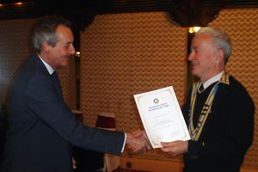  President Walter handing the letter of appreciation to John Fry
Warm Wishes
Rotary Club of Kathmandu Mid-Town would like to felicitate PP Giri and Lochan for their companionship. We wish them a happy life together.

Induction of Two New Members
On February 7th, our Club inducted two new members, Mr. Shyam Thapaliya and Mr. Peter Morris. PP Mani read the text, and PP Ambica, PP Giri, PP Komal and Rtn. Peter Clawson all took turns in reminding the new members of their duties and responsibilities as well as their privileges. CP Roop presented the new members with their Rotary pins.
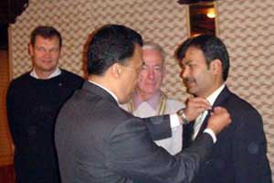 | 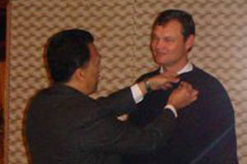
CP Roop places the Rotary pin on newly inducted member of our club Rtn. Shyam Thapaliya | CP Roop places the Rotary pin on newly inducted member of out club Rtn. Peter Morris

THE NEPAL ROTARY ► NEWS
Condolence

Mr. Gopal Raj Bhandari, a senior Rotarian and the founder of Mercantile Group, passed away at Gleneagles Hospital in Singapore on February 17 at 5pm local time at the age of 87. The last rites of Mr. Raj Bhandari were performed at Pashupati Aryaghat in Kathmandu onTuesday, February 19. He had been battling cancer for the last 8 months. He was a well known and well respected personality in the Rotary. He was awarded the prestigious “Service above Self” award from Rotary International for the year 2002 for his contributions to Rotary projects.
Rotary Club of Kathmandu Mid-Town wishes to extend heartfelt condolence to the bereaved family members.

Editor: Rabi Karmacharya, Club Service Director email: rabikarma@gmail.com

Original Message -----
From: Rabi Karmacharya
To: undisclosed-recipients:
Sent: 21 February, 2008 16:33
Subject: BC Vol 20 07-08

Latest edition of our Breakfast Chatter. Enjoy.
-Rabi
Club Service Director 2007-08

